 



Database Programming with SQL 13-2: Using Data Types

Practice Activities

# Objectives

* Create a table using TIMESTAMP and TIMESTAMP WITH TIME ZONE column data types
* Create a table using INTERVAL YEAR TO MONTH and INTERVAL DAY TO SECOND column data types
* Give examples of organizations and personal situations where it is important to know to which time zone a date-time value refers
* List and provide an example of each of the number, date, and character data types

# Vocabulary

Identify the vocabulary word for each definition below.

|  |  |
| --- | --- |
| **INTERVAL YEAR**[(x)] **TO MONTH (x по умолчанию 2)** | Allows time to be stored as an interval of years and months |
| **TIMESTAMP** [(точность дробной части)] **WITH LOCAL TIME ZONE** | When a column is selected in a SQL statement the time is automatically converted to the user’s timezone |
| **BLOB** | Binary large object data up to 4 gigabytes |
| **TIMESTAMP** [(точность дробной части)] **WITH TIME ZONE** | Stores a time zone value as a displacement from Universal Coordinated Time or UCT |
| **INTERVAL DAY**[(x)] **TO SECOND**[(y)] x -по умолчанию 2, y – по умолчанию 6 | Allows time to be stored as an interval of days to hours, minutes, and seconds |
| **CLOB** | Character data up to 4 gigabytes |
| **TIMESTAMP** [(дробная часть точность)] | Allows the time to be stored as a date with fractional seconds |

# Try It / Solve It

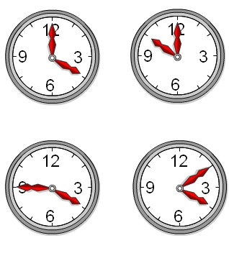

**LONDON**

**NEW YORK**

t

1. Using the examples provided in the slides, create each

h of the three time-zone tables.

ions

e-time

* 1. TIMESTAMP WITH LOCAL TIME ZONE

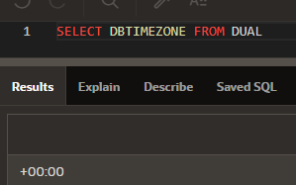

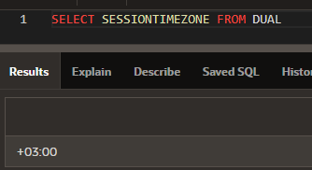

CREATE TABLE time_ex3 (first_column TIMESTAMP WITH TIME ZONE,

second_column TIMESTAMP WITH LOCAL TIME ZONE);

INSERT INTO time_ex3

(first_column,

second_column)

VALUES

(TO_TIMESTAMP_TZ('2016-11-0116:02:08.236+05:30','YYYY-MM-DDHH24:MI:SS.FFTZH:TZM'),

TO_TIMESTAMP_TZ('2016-11-0116:02:08.236+05:30','YYYY-MM-DDHH24:MI:SS.FFTZH:TZM'));

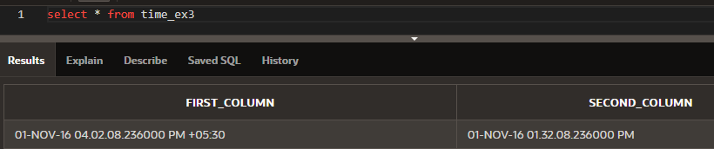

* 1. INTERVAL YEAR TO MONTH

CREATE TABLE time_ex4

(loan_duration1 INTERVAL YEAR(3) TO MONTH,

loan_duration2 INTERVAL YEAR(2) TO MONTH);

INSERT INTO time_ex4 (loan_duration1, loan_duration2 )

VALUES( INTERVAL '120' MONTH(3), INTERVAL '3-6' YEAR TO MONTH);

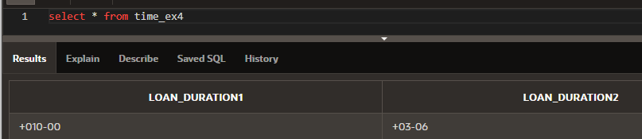

* 1. INTERVAL DAY TO SECOND

CREATE TABLE time_ex5

(day_duration1 INTERVAL DAY(3) TO SECOND,

day_duration2 INTERVAL DAY(3) TO SECOND);

INSERT INTO time_ex5 (day_duration1, day_duration2 )

VALUES( INTERVAL '25' DAY(2), INTERVAL '4 10:30:10' DAY TO SECOND);

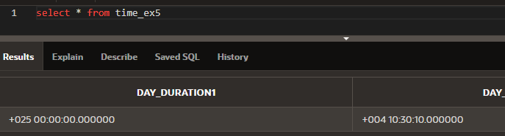

1. Execute a SELECT * from each table

to verify your input.

SELECT * FROM time_ex3;

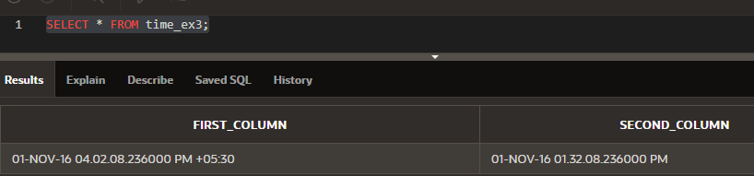

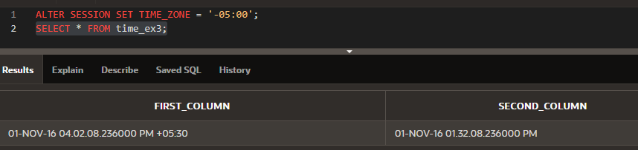

SELECT TO_CHAR( SYSDATE + loan_duration1 , 'DD-Month-YYYY') AS "120 months from Now", TO_CHAR( SYSDATE + loan_duration2 , 'DD-Month-YYYY') AS "3 years 6 months from Now"

FROM time_ex4;

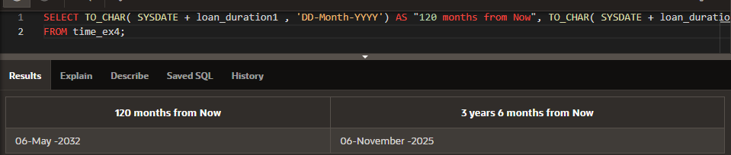

SELECT

TO_CHAR( SYSDATE , 'DD-Month-YYYY hh:mi:ss') AS now,

TO_CHAR( SYSDATE + day_duration1 , 'DD-Month-YYYY hh:mi:ss') AS "25 days from Now",

TO_CHAR( SYSDATE + day_duration2 , 'DD-Month-YYYY hh:mi:ss') AS "4day10hr30min10sec from now "

FROM time_ex5;

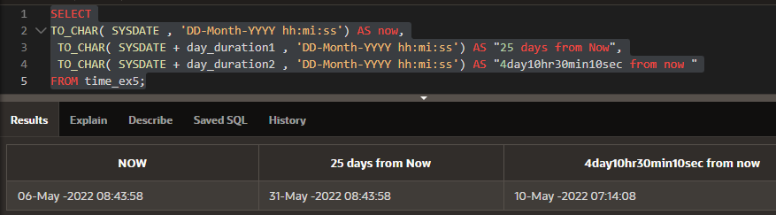

1. Give 3 examples of organizations and personal situat where it is important to know to which time zone a da value refers.

Любые события, которые планируются в текущей локали, например:

- встреча коллег

- учет времени прихода на работу

- планирование отпусков

Copyright © 2020, Oracle and/or its affiliates. All rights reserved. Oracle and Java are registered trademarks of Oracle and/or its affiliates. Other names may be trademarks of their respective owners.